

**“**Power BI Powered Global Terrorism Dataset Analysis **”**



**“S. T. HINDU COLLEGE, NAGERCOIL”**

|  |  |
| --- | --- |
| **NM ID** | **NAME** |
| asmsu31520213151517126 | RANZUKTHA SRI G V |

Trainer Name : R UMAMAHESWARI

Master Name : R UMAMAHESWARI

# ABSTRACT

Terrorist attacks pose a great threat to global security, and their analysis and prediction are imperative. Considering the high frequency of terrorist attacks and the inherent difficulty in finding related terrorist organizations, we propose a classification framework based on ensemble learning for classifying and predicting terrorist organizations. The framework includes data preprocessing, data splitting, five classifier prediction models, and model evaluation Based on a quantitative statistical analysis of terrorist organization activities in GTD from 1970 to 2017 and feature selection using the SelectKBest method in scikit learn, we constructed five classification and prediction models of terrorist organizations, namely, decision tree, bagging, random forest, extra tree, and XGBoost, and utilized a 10-fold cross-validation method to verify the performance and stability of the proposed model. Experimental results showed that the five models achieved excellent performance. The XGBoost and random forest models achieved the best accuracies (97.16% and 96.82%, respectively) of predicting 32 terrorist organizations with the highest attack frequencies. The proposed classifier framework is useful for the accurate and efficient prediction of terrorist organizations responsible for attacks and can be extended to predict all terrorist organizations.

## INDEX

|  |  |  |
| --- | --- | --- |
| **S. No.** | **Table of Contents** | **Page No.** |
| 1 | Chapter 1: Introduction | 4 |
| 2 | Chapter 2: Services and Tools Required | 6 |
| 3 | Chapter 3: Project Architecture | 8 |
| 4 | Chapter 4: Modeling and Result | 10 |
| 5 | Conclusion | 15 |
| 6 | Future Scope | 16 |
| 7 | References | 17 |

**CHAPTER 1**

## INTRODUCTION

In today’s world Terrorism is the most direct asymmetric threat to the security of the citizens of NATO countries, and to international stability and prosperity. A persistent global issue that knows no border, nationality or religion, terrorism is a challenge that the international community must tackle together. NATO will continue to fight this threat with determination and in full solidarity. NATO’s work on counter-terrorism focuses on improving awareness of the threat, developing capabilities to prepare and respond, and enhancing engagement with partner countries and other international actors

**1.1 Contextualizing the Threat:**

Terrorism poses a multifaceted threat to societies worldwide, with its impacts transcending national borders. Understanding the historical, political, and social contexts in which terrorism arises is crucial for formulating effective responses. By examining the historical evolution of terrorist tactics and ideologies, we can gain valuable insights into the current landscape of global terrorism.

**1.2 Temporal Analysis:**

By analyzing temporal trends in terrorist incidents, we aim to identify patterns and fluctuations in the frequency and severity of attacks over time. Understanding how these trends correlate with geopolitical events, policy changes, and technological advancements can provide valuable insights into the evolving nature of terrorism and potential future threats.

**1.3 Geospatial Mapping:**

Mapping the geographical distribution of terrorist activities allows us to identify hotspots and regions of heightened risk. By examining factors such as political instability, socioeconomic disparities, and ethnic tensions, we can gain a deeper understanding of the underlying drivers of terrorism in different regions and countries.

**1.4 Characteristics of Terrorist Incidents:**

Delving into the characteristics of terrorist incidents, including the types of attacks employed, the choice of targets, and the identities of the perpetrators, offers insights into the motivations, ideologies, and operational capabilities of terrorist groups. By analyzing these factors, we can develop targeted strategies to disrupt terrorist networks and prevent future attacks.

**1.5 Advanced Analytical Techniques:**

Leveraging advanced analytical techniques such as clustering and trend analysis allows us to uncover hidden relationships and emergent patterns within the data. By identifying clusters of similar incidents and examining their evolution over time, we can discern underlying dynamics and anticipate future trends in terrorism, thereby enhancing our ability to proactively address emerging threats.

## CHAPTER 2

**SERVICES AND TOOLS REQUIRED**

### 2.1 Services Used

**Data Collection and Storage Services:**

* **Global Terrorism Database (GTD):** Provides detailed information on global terrorist incidents.
* **Azure Data Lake Storage:** Cloud-based storage for scalable and secure storage of the GTD dataset.
* **Amazon S3 (Simple Storage Service):** Scalable object storage service for storing large datasets like GTD securely.

**Data Processing Services:**

* **Azure Data Factory:** Creates data pipelines for extracting, transforming, and loading GTD data into Power BI.
* **AWS Glue:** Automates data cleaning and transformation tasks to prepare GTD data for analysis in Power BI.

**Machine Learning Services:**

* **Azure Machine Learning:** Develops predictive models to analyze GTD data for trends and patterns.
* **Amazon Sage Maker:** Builds, trains, and deploys machine learning models for analyzing GTD data at scale.

### 2.2 Tools and Software used

**Tools**:

* **Power BI:** Create interactive dashboards and reports to visualize trends and insights from the terrorism dataset. Define relationships between data tables for comprehensive analysis. Seamlessly integrate Power Query for data preparation and transformation directly within Power BI.
* **Power Query:** Clean, transform, and shape the terrorism dataset before loading it into Power BI. Connect to diverse data sources, including the Global Terrorism Database (GTD), for extraction.Utilize advanced features like custom functions and conditional logic for sophisticated data processing.

**Software Requirements**:

* **Power BI Desktop**: This is a Windows application that you can use to create reports and publish them to Power BI.

* **Power BI Service**: This is an online SaaS (Software as a Service) service that you use to publish reports, create new dashboards, and share insights.

* **Power BI Mobile**: This is a mobile application that you can use to access your reports and dashboards on the go.

## CHAPTER 3

**PROJECT ARCHITECTURE**

**3.1 Architecture**

### USER FRONTEND BACKEND

**Power BI 2.126**  **Datasets**



### (Excel)

Here’s a high-level architecture for the project:

1. **Data Collection**: Data collection involves accessing and downloading the Global Terrorism Database (GTD) and importing the dataset into Power BI for analysis.
2. **Data Storage**: Data storage entails importing data from an Excel file into Power BI. Users can then analyze the data and derive insights within the Power BI environment.
3. **Data Processing**: Data processing involves cleansing, transforming, and structuring raw data from various sources, such as Excel or databases, to prepare it for analysis within Power BI, ensuring accuracy and relevance for insights generation.
4. **Machine Learning**: Machine learning involves leveraging algorithms and statistical models to enable computers to learn from and make predictions or decisions based on data, which can be integrated with Power BI for advanced analytics and predictive insights generation..
5. **Data Visualization**: Data visualization refers to the graphical representation of data through charts, graphs, maps, and other visual elements within Power BI, enabling users to interpret and understand complex datasets, identify patterns, trends, and outliers, and communicate insights effectively..
6. **Data Access**: The dashboards created in Power BI Can be accessed through Power BI Desktop, Power BI service (online),and Power BI mobile.

.

This analytical framework offers a comprehensive solution for conducting real-time analysis of global terrorism data. Nonetheless, it's crucial to acknowledge that the architectural specifics could vary based on existing infrastructure, particular needs, and budget constraints. Furthermore, adherence to pertinent data privacy and security regulations is imperative across all utilized tools and services.

**CHAPTER 4**

## MODELING AND RESULT

### Manage relationship

In the context of a global terrorism analysis in Power BI, "manage relationship" involves establishing and managing connections between tables containing different aspects of terrorism data, such as incidents, perpetrators, and locations. These relationships enable users to perform comprehensive analyses across various dimensions of terrorism-related information, facilitating a deeper understanding patterns, trends, and correlations within the dataset.

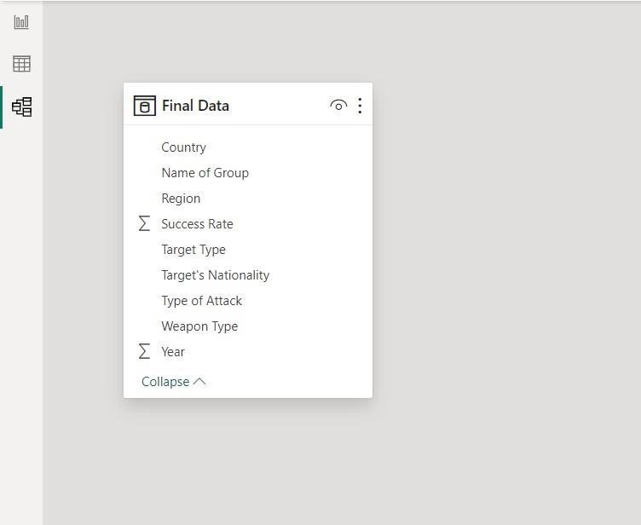

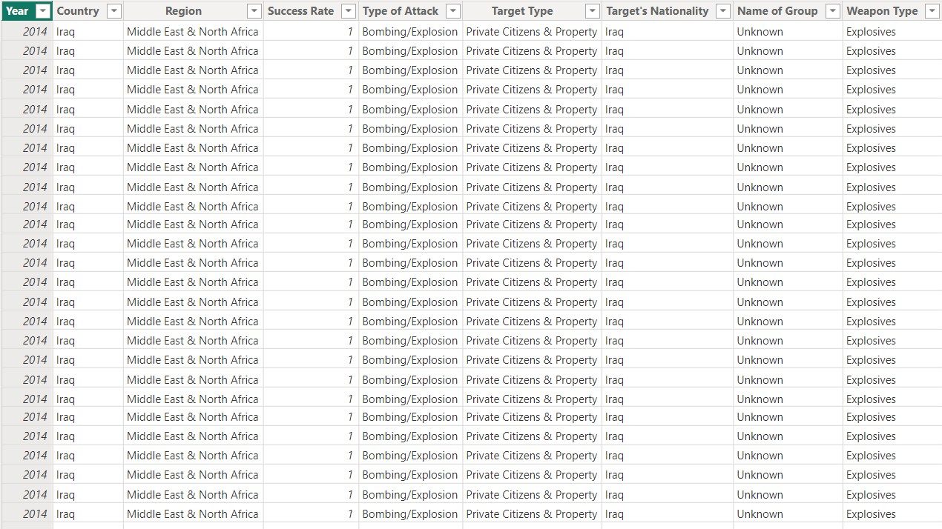

#### Modelling for Country and Year data

In Power BI, modeling for year and country involves creating relationships between tables containing data on years, countries, and other relevant information. Import your dataset into Power BI. Ensure that it includes tables for years, countries, and any other relevant data, such as terrorism incidents

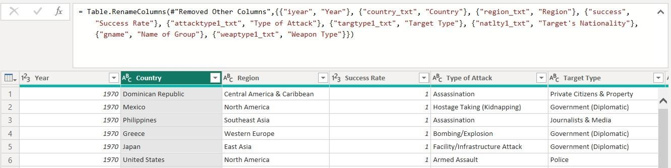

Similarly, create relationships between the country table and any other tables containing country-related information, such as the table with terrorism incidents. Ensure that the relationships are set up correctly based on the shared country columns.

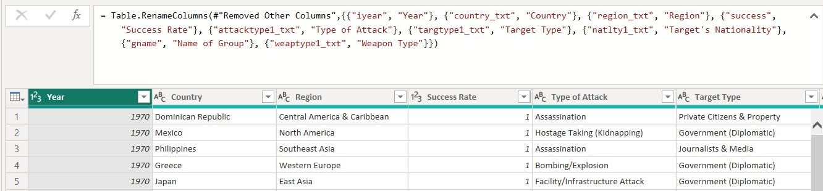

#### Replacing values

Set some fields to English for easy understanding, we replace values to English with the Power Query Editor.

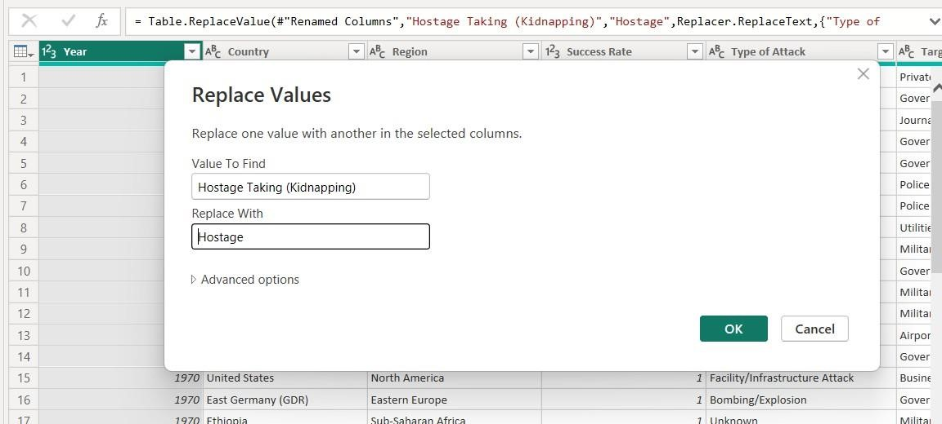

#### Grouping of age by ranges

To group years into ranges in Power BI, create a new column using the "New Column" option in the "Modeling" tab. Use an IF or SWITCH statement in the formula bar to categorize the years into desired ranges. For example, you can define ranges such as "2000-2005," "2006-2010," and so on. Give the new column a descriptive name, like "Year Range," and then close and apply the changes. This will create a new column in your dataset that groups years into specified ranges, allowing for easier analysis and visualization of trends over time.

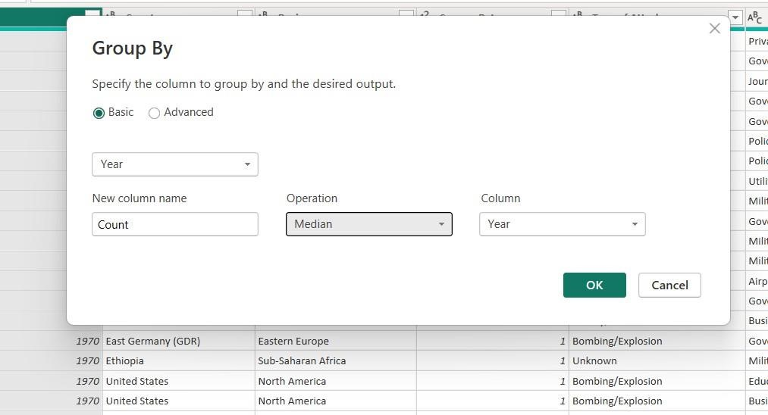

## Dashboard

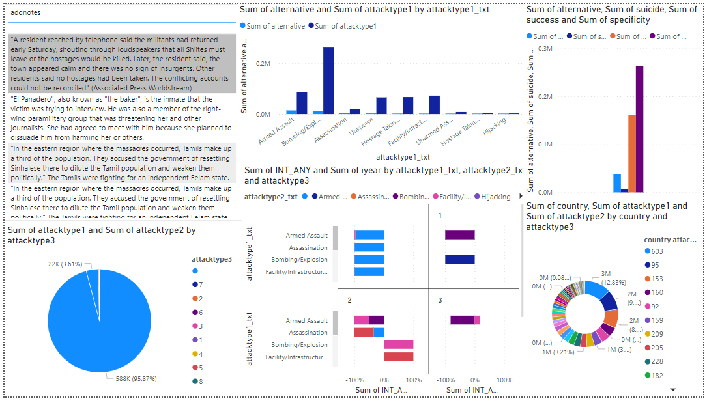

### CONCLUSION

### In this study, through a quantitative analysis of the data in the GTD, ensemble machine learning has been used to construct five multiclass classification models for the prediction of terrorist organizations that perpetrated terrorist attacks

### First, according to the frequency of terrorist organization attacks, the terrorist organizations were analyzed, and the characteristics and trends of 32 terrorist organizations with more than 500 terrorist attacks were described in detail. Then, for the prediction of terrorist organizations in terrorist attacks, 36 feature attributes were selected based on the feature selection strategy, and five classifiers, including decision tree, bagging, random forest, extra tree, and XGBoost, were constructed to predict terrorist organizations. The performance and stability of the five models were evaluated using hold-out and 10-fold cross-validation methods, respectively. Our models predicted 32 terrorist organizations for high-frequency activities in terrorist attacks. Finally, the experimental results showed that the five models achieved good performance and stability. XGBoost and the random forest classifier achieved the best prediction accuracies of 97.15% and 97.03%, respectively. We further visualized and analyzed the prediction results of the XGBoost. Model using the confusion matrix. Moreover, the method can be extended to the prediction of a broader range of terrorist organizations. Considering the number of terrorist organization classifications based on the frequency of attacks, the classification prediction accuracy of the random forest algorithms was consistently excellent. When the number of terrorist organizations was small (e.g.. dozens). XGBoost exhibited the best prediction accuracy, and the performance of random forest was close to that of XGBoost,

### The prediction model presented herein can macroscopically predict the terrorist organizations of global terrorist attacks, excavate the relevant factors of terrorist attacks, and provide decision support for the prevention and control of anisienotism organizations and related counities. With further improvement in the performance and accuracy of machine learning algorithms, we believe that these technologies can help security departments find better algorithmic models and appropriate datasets to improve the accuracy of predictions related to terrorist attacks. However, considering the local sparsity of terrorist attacks and their versatility in planning and execution,

**FUTURE SCOPE**

The future of terrorism and terrorism of the future are two different issues. It can be safely said that the future of terrorism is, in a manner of speaking, “secure” in that society and states that may be able to manage terrorism with the correct instruments and policies but it cannot be totally eliminated from society no matter what laws and counter-terror measures that are taken Some terrorist groups fade away quickly, almost as suddenly as they appeared on the scene, while others run through a mixture of fluctuating fortunes depending on the kind of support they are able to derive from their benefactors and empirical geopolitical conditions that exist and which might vary. For long, it was considered that Islamic terrorism was something that happened only in Africa and Asia untill 11 September, 2001. The narrative began to change but not fast enough. Today, terror is to be found in San Bernardino in California, Orlando in Florida USA, Brussels and Paris; the idea is spreading from West Asia but the act often carried

Out by the locals. The narrative still has not changed adequately enough.

Besides the need to eliminate radical Islamic terrorism through military domination, it is

Necessary that the voice of the moderate must be strengthened for the battle is internal, within Islam as well. But so long as pre-eminent global leaders like President Obama and US Presidential hopefuls like Hillary Clinton fudge and refuse to describe recent attacks in Orlando as Islamic terror and bend the narrative away from this, the moderate feels weakened. This is precisely what moderate Muslims settled in the West and even in some Muslim countries have been urging. If the power that proclaims to lead the world in getting rid of terrorism is unable to unequivocally condemn such acts of Islamic terror, then this only strengthens radical Islamist.

### REFERENCES

* <https://www.hindawi.com/journals/sp/2021/7890923/>
* <https://www.analyticsvidhya.com/blog/2022/03/exploratory-data-analysis-on-terrorism-dataset/>
* <https://www.mdpi.com/2071-1050/13/14/7598>

**LINKS**

<https://github.com/search?q=Global%20terrorism%20dataset%20analysis%20&type=repositories>